MACHINE LEARNING AND DATA SCIENCE
CAPE STONE PROJECT

Dataset:
teen_phone_addition_dataset
Domain:
Supervised Learning.(Requirements clear. Proper Input & Output.)
The output of our dataset is Continuous Value. So it comes under Regression.
Finding Best Model:
Using Feature Selection Method (selectkbest) we can find out the best model. Using this method, we identified SUPPORT VECTOR MACHINE NON LINEAR is the best model. So we forward the model in deployment phase.
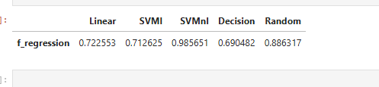
Best Feature in our dataset:
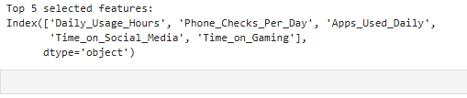
During deployment phase, we should only assign value to the column name mentioned above.
Before deployment phase we should
    - Check NULL Values,Missing Values
    - Do Data Preprocessing
    - Find outliers
Check NULL Values,Missing Values:
Using the following coding we can check null values dataset.isnull().sum()
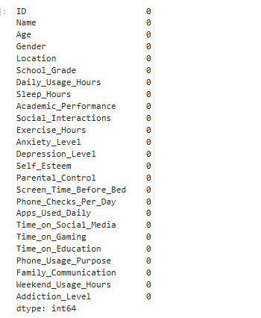

Data Science-Univariant Analysis
Finding outlier:
- If Min value is less than Lesser Outlier then the particular column is Lesser Outlier.
- If Max value is greater than Greater Outlier then the particular column is Greater Outlier
In our dataset Outliers are listed below
Handling Outlier:
Lesser Outlier is replace with MIN Value.Greater Outlier is replace with MAX Value.
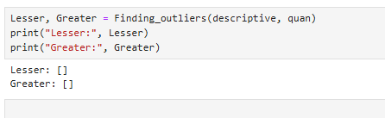

Normal Distribution:
A large number of teens have low addiction level.Moverover smaller number of teens have high addictional level that is shown in following Fig(1).

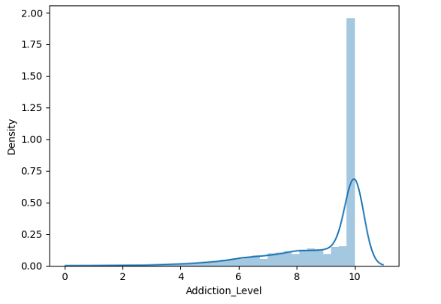
Fig(1)
Probability Density Function:
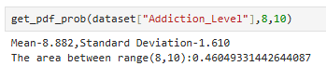
Approximately 46.04%, that is nearly half of teens in the dataset fall with in this range (8 to 10).See the following Fig(2)

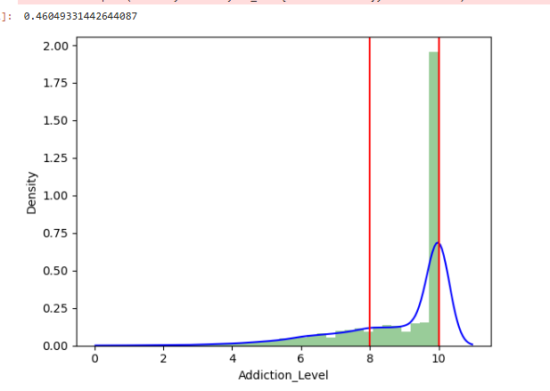
Fig(2)
Standard Normal Distribution:
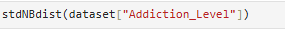
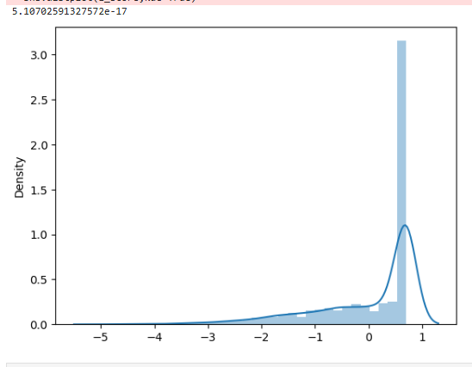
Based on this image, most teens have addiction levels close to near average, few teens has extreme level.
Data Science-Bivariant Analysis
Covariance:
It tells about the difference between two columns. For example difference
between Depression_Level & Sleep_Hours is -0.049306.This is Negative Covariance (ie) Depression_Level is increase Sleep_Hours is decrease and vice versa.
dataset[quan].cov()

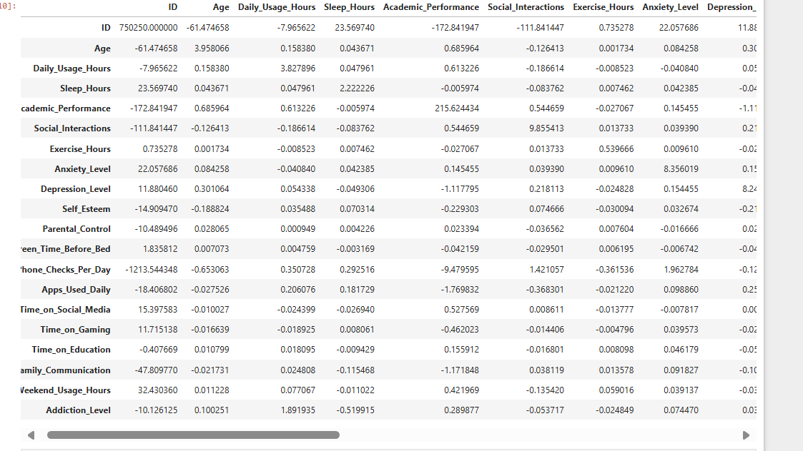

Correlation:
It tells about the relation between two columns.The relation between Time_on_Gaming and Addiction_level is 0.273060.This is positive correlation (ie) Time_on_Gaming is increase Addiction_level is also increase.
dataset[quan].corr()
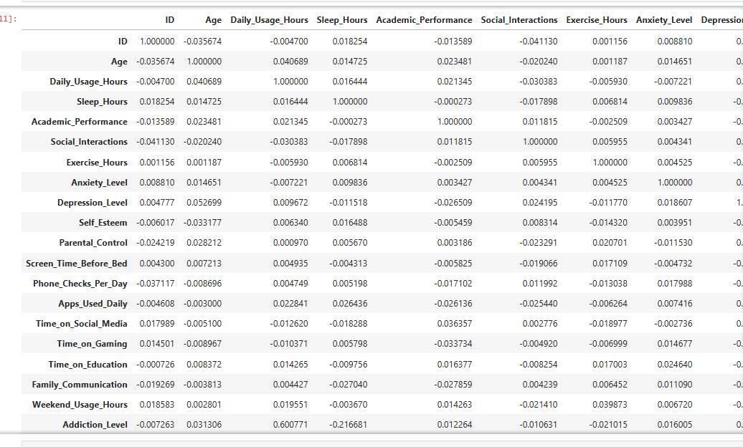
Variance Inflation Factor(VIF):
To overcome Multicolinearity(two or more independent variable in linear model) by using VIF.

If VIF is
1 Not Correlated
Between 1&5 Moderately Correlated
Greater than 5 highly correlated
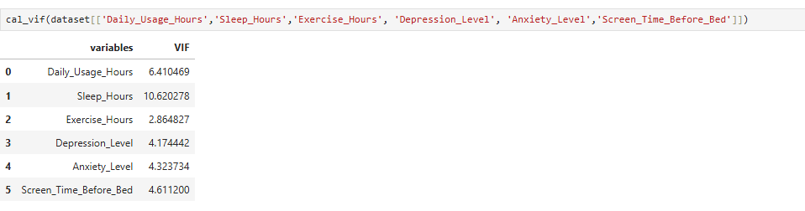
Based on the output
Daily_usage_Hours is highly correlated
Sleep_Hours is very highly correlated
Exercise_hours,Depression_Level,Anxiety_Level, Screen_Time_Before_Bed is moderately correlated
Ttest:
To find similarity between two groups based on Mean. It has two types
    - Paired
    - UnPaired

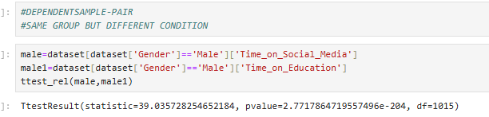
Since the p-value < 0.05, you reject the null hypothesis.
Interpretation:
There is a statistically significant difference in the time that male spends on social media compared to the time they spend on education.
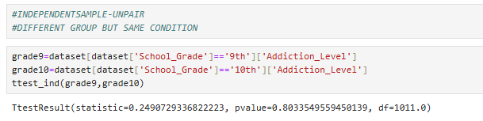
The p-value (0.803) is greater than 0.05, we fail to reject the null hypothesis. This means there is no statistically significant difference between the Addiction Levels of 9th and 10th grade students.
Analysis of Variance (ANAVO):
ANAVO method is used to compare the means of 3 or more groups to see atleast one group’s mean is significantly different from the others.It has two types
      - One-way ANOVA
      - Two-way ANOVA
One-way:
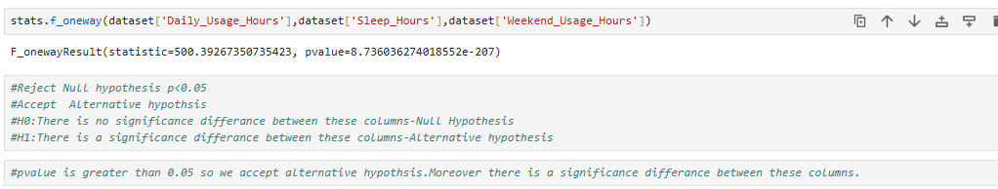
Two-way:
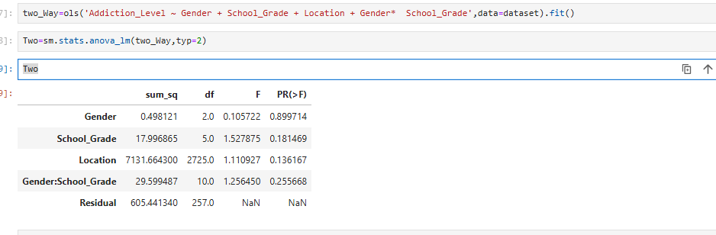

Data Visualization-Univariant Analysis
It represent the data in visual form and easy to understand the relationship between data.
Distribution plot:
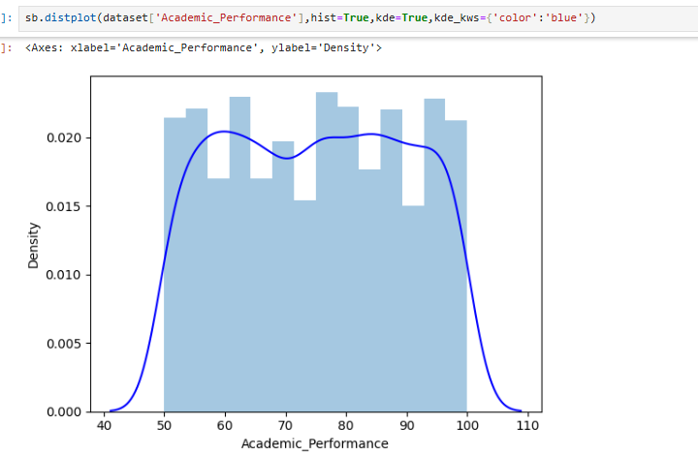
The graph visually demonstrates how "Academic Performance" is distributed across the dataset. Moreover peaks around 60-65, 75-80, and 90-95 that mean most of the students fall between these ranges.

Data Visualization-Bivariant Analysis
Joint plot:
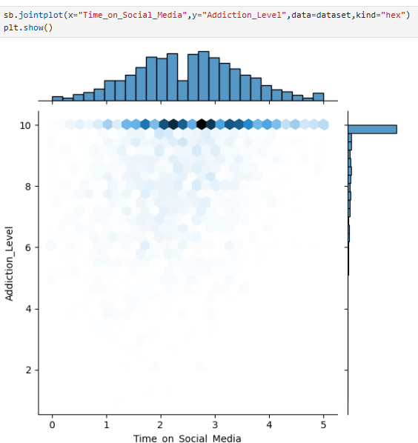
In the above graph Dark blue indicate more students spending that specific amount of time on social media at that particular Addiction_Level. Light blue indicate less students spending that specific amount of time on social media at that particular Addiction_Level.
Top Side Histogram shows the distribution of Time on Social Media. Most of the students are grouped in the lower to mid range that is low to medium amount of time used in social media.
Right Side Histogram shows the distribution of Addiction_Level.Many students have higher addiction level (close to 10).
Strip plot:(for Categorial Data)
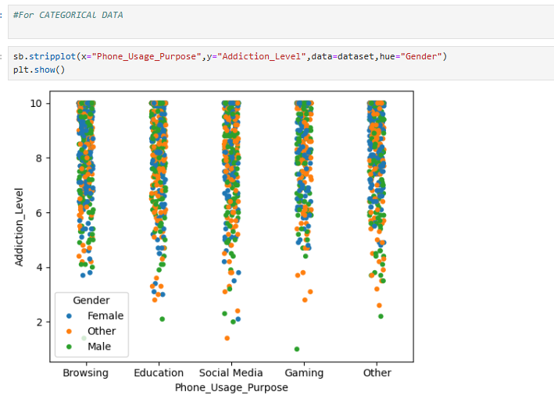
In the above graph Browsing, Social Media, Gaming --> most Addictional_Level are pointed between 5 to 10.Education is less extreme level compared to Browsing, Social Media, Gaming.
Other purposes the pointes are more widely spread out, with only a few cases reaching the maximum Addiction Level of 10.Both male and female teenagers are approximately same Addiction Level.
Violin plot:(for Categorial Data vs Numercial Data)
In the following graph Wider part of blue area indicate more individuals have that addiction level. Narrow part indicate fewer individuals at that level.White dot inside the violin shape indicate the average value. Thick Black bar indicate IQR (middle 50% of the data).
All the gender(male,female,other)have similar distribution level.Most addiction levels are concentrated between 6 and 9,showing high tendency toward phone addiction.Very few cases are near 0-2 or 10

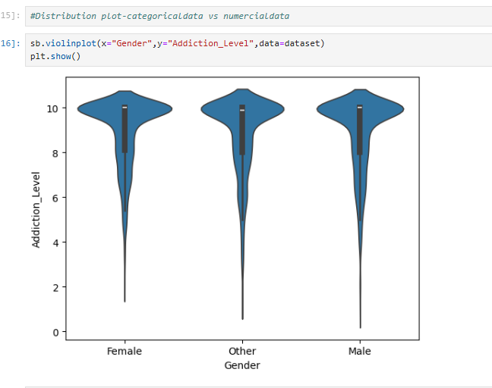

Data Studio-Tableau Public
- What is the Maximum daily phone usage time for each gender categorized by grade?
- How does the minimum addiction level vary by grade?
- What is the median depression level based on gender?
- What is the 25th percentile of addiction level based on phone usage purpose?
- What is the total count of exercise hours and phone checks per day?
- Which gender spends the most time on social media and education?

